PRACTICAL LIST – AY: 2026- 27
Sr. no. | Title | CO/PO
 | Title: API Testing using Postman  Aim: To perform functional testing of REST APIs by validating requests, responses, status codes, headers, and response time using Postman.  Software/Tools Required  - Postman  - Web Browser  - Internet Connection  - Public REST API (e.g., JSON Placeholder)  Procedure  - Install and launch Postman.  - Send a GET request to retrieve data from a REST API.  - Send a POST request with sample JSON data.  - Validate the HTTP status code.  - Verify the response body and headers.  - Measure the response time.  - Save the requests in a Postman Collection.  - Record the observations.  Expected Outcome: REST APIs are successfully validated for functionality and correctness.  Result: Test and validated API calls | CO4 / PO1, PO2, PO3, PO5 and PO12
Solution:
- Install and open Postman or signup for https://www.postman.com/
- Then create a new HTTP request

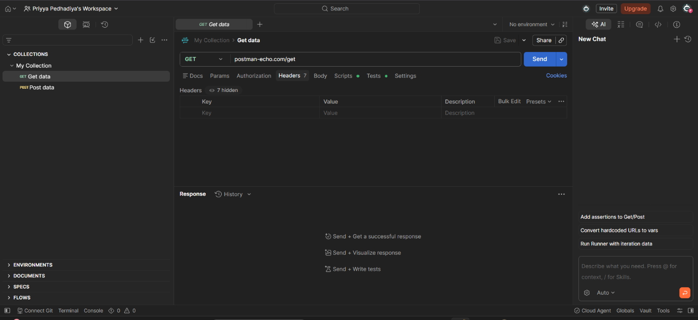
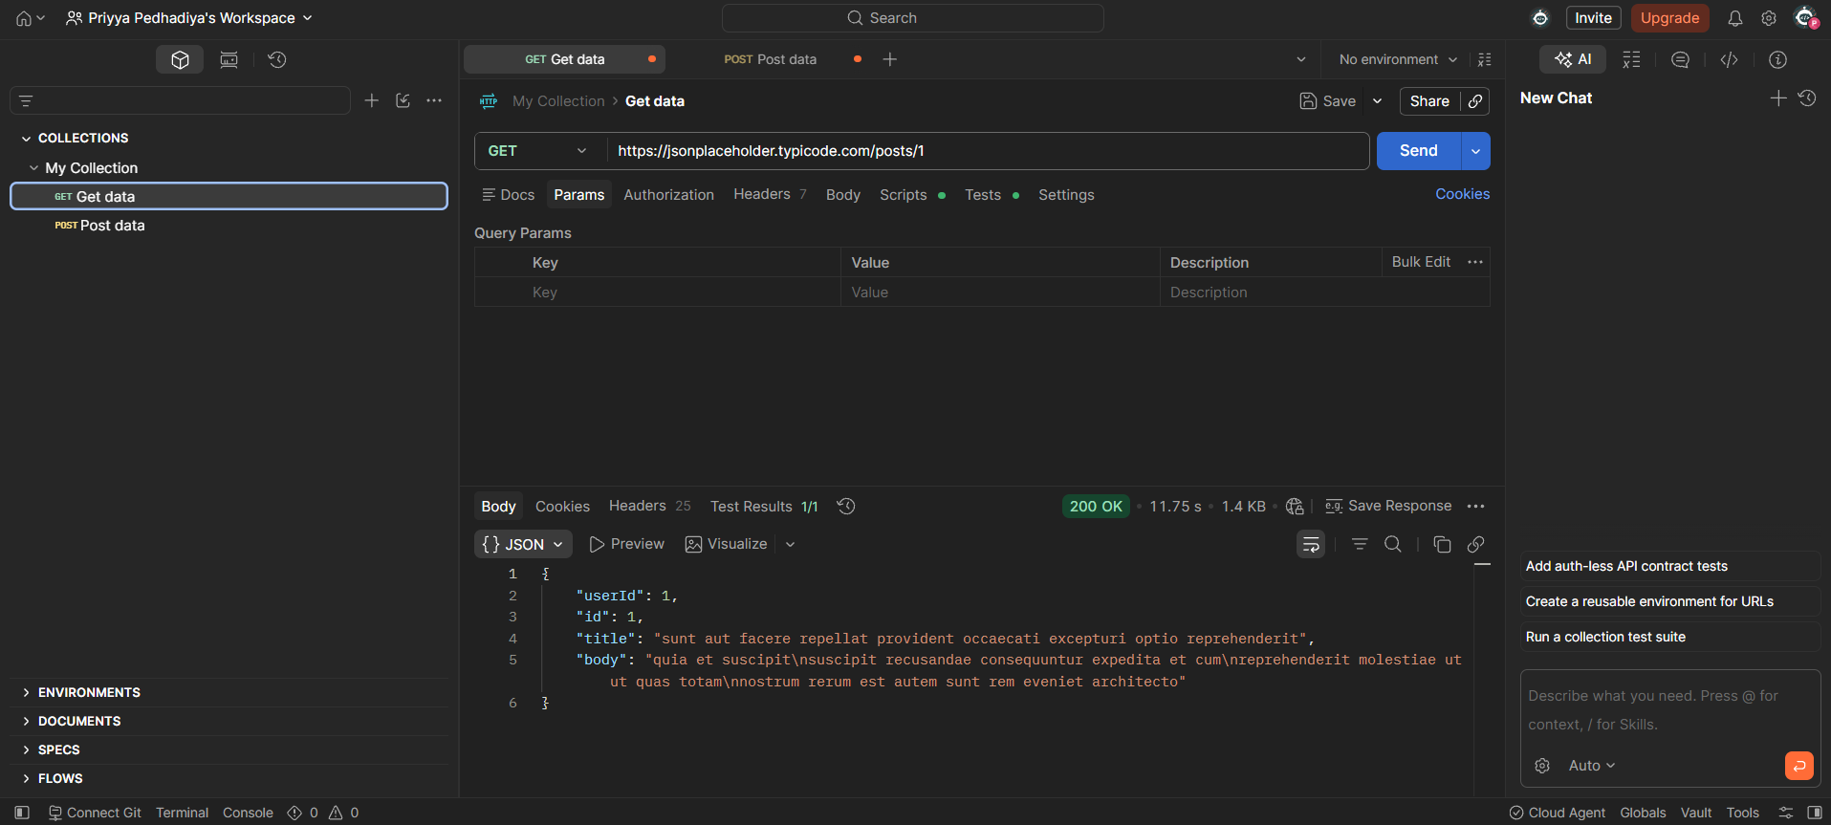
- Send a GET request to https://jsonplaceholder.typicode.com/posts/1 and verify the response data and 200 OK status code.

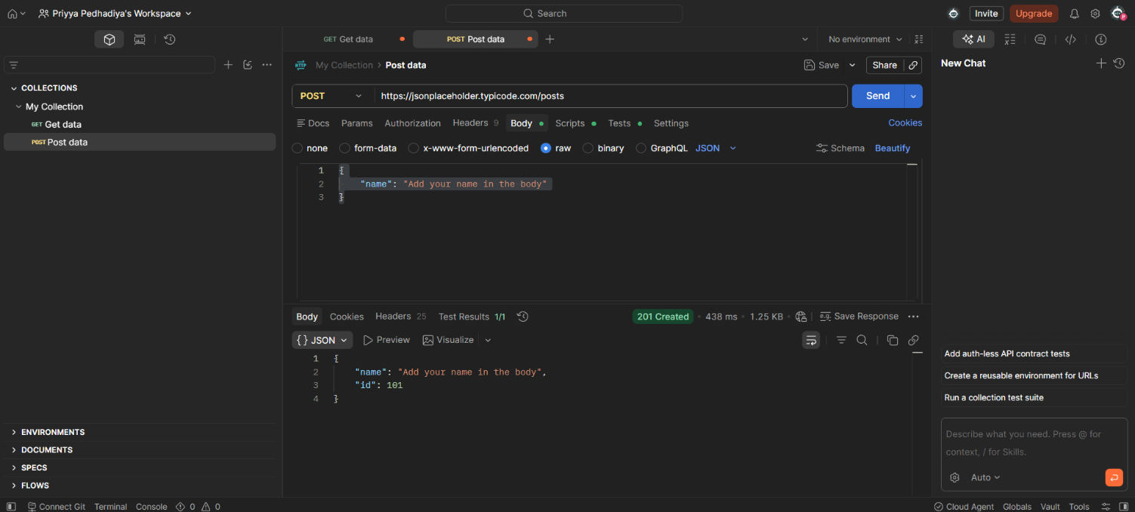
- Create a POST request, enter sample JSON data in the request body, and send the request.

- Verify that the response returns the created data with the 201 Created status code.

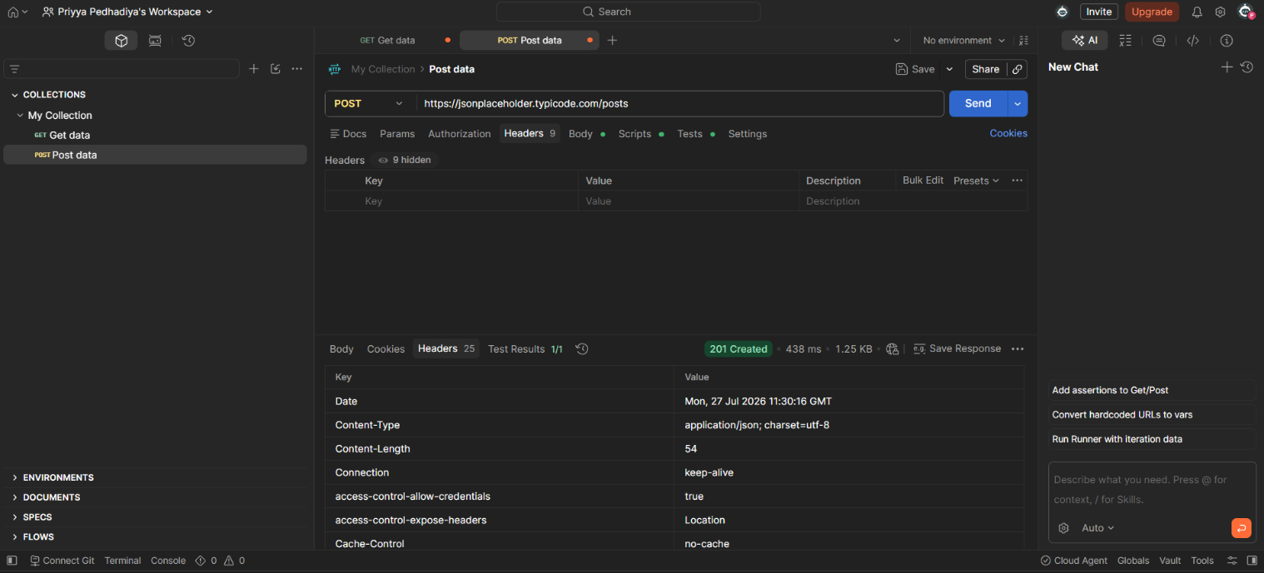
- Check the response headers, response body, and response time for both requests.

- Save the requests in a Postman Collection and record the observations and results.
Sr. No. | Test Performed | Observation
1 | GET Request (/posts/1) | Response received successfully with 200 OK status code.
2 | POST Request (/posts) | Data was created successfully with 201 Created status code.
3 | Response Body | JSON data was returned correctly.
4 | Response Headers | Headers such as Content-Type, Content-Length, and Date were verified successfully.
5 | Response Time | Response was received within an acceptable time limit.
6 | Collection | Both GET and POST requests were saved successfully in the My Collection collection.

Result:
The REST APIs were successfully tested using Postman. GET and POST requests were executed successfully, and the status codes, response body, response headers, and response time were verified. The requests were saved in a Postman Collection, and the API functionality was validated successfully.
Reference Youtube Video:
https://www.youtube.com/watch?v=wEOLZq-7DYs

